

Draw It or Lose It

# **CS 230 Project Software Design Template**

Version 1.0

## Table of Contents

**CS 230 Project Software Design Template**1

**Table of Contents**2

**Document Revision History**2

**Executive Summary**3

**Design Constraints**3

**System Architecture View**3

**Domain Model**3

**Evaluation**3

**Recommendations**5

## Document Revision History

| Version | Date | Author | Comments |
| --- | --- | --- | --- |
| 1.0 | 08/01/2021 | Michael Richards | Initial prototype software design |

**Instructions**

Fill in all bracketed information on page one (the cover page), in the Document Revision History table, and below each header. Under each header, remove the bracketed prompt and write your own paragraph response covering the indicated information.

## Executive Summary

The Gaming Room currently has available an Android app called Draw It or Lose It. They would like to develop a web-based game that serves multiple platforms based off the current game. The game consists of multiple games which host multiple-teams, and each team has multiple players. For the game to function properly each game and team name needs to be unique. Draw It or Lose It contains a large library of stock drawings. The staff at The Gaming Room do not know how to set up the environment.

## Design Constraints

Android, IOS, and the web all have different software development kits.

It should be tailored to work with 3 different platforms.

It needs to be able to allow 1 or more teams from any of the platforms.

Game and team names must be unique.

The ability to alert a team if a team name already exists and allow them to choose another one.

Use unique IDs for each instance of a game, team, and player to limit instances of the game to one.

## System Architecture View

Please note: There is nothing required here for these projects, but this section serves as a reminder that describing the system and subsystem architecture present in the application, including physical components or tiers, may be required for other projects. A logical topology of the communication and storage aspects is also necessary to understand the overall architecture and should be provided.

## Domain Model

The ProgramDriver Class has the main method. ProgramDriver uses Directed Association with SingletonTester to test of there is already an instance of GameService. The Entity class is the parent class to Game, Team, and Player classes. Game Service must only have one instance of each game running at any time. Each Game can only have one unique Team at any time. Each Team can only have one of Each individual Player at one time.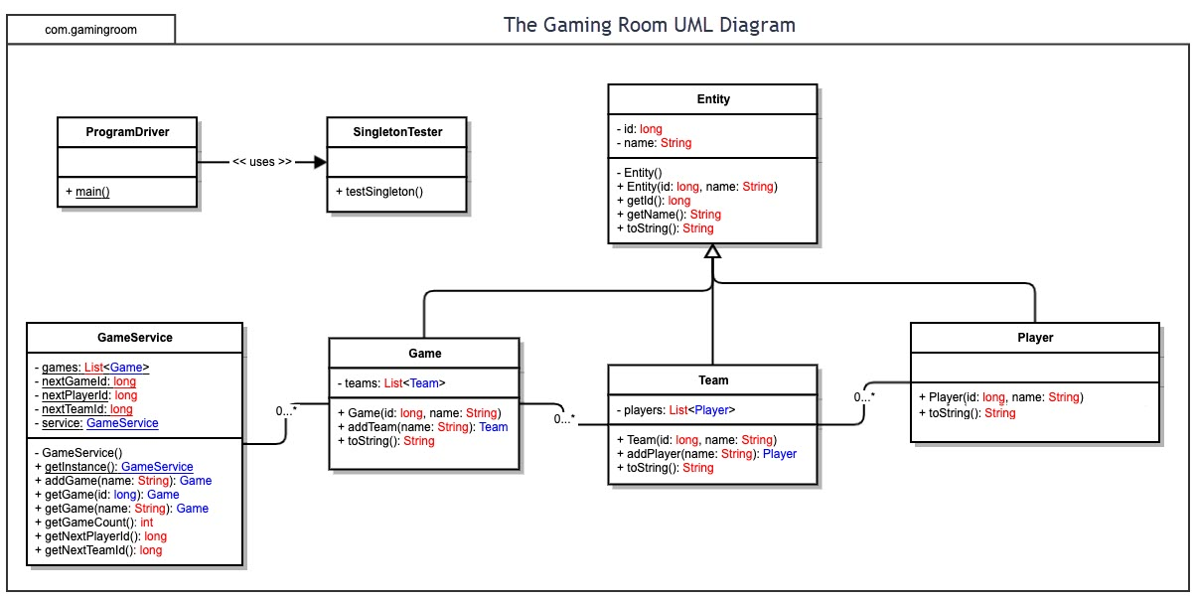

## Evaluation

Using your experience to evaluate the characteristics, advantages, and weaknesses of each operating platform (Linux, Mac, and Windows) as well as mobile devices, consider the requirements outlined below and articulate your findings for each. As you complete the table, keep in mind your client’s requirements and look at the situation holistically, as it all has to work together.

In each cell, remove the bracketed prompt and write your own paragraph response covering the indicated information.

| **Development Requirements** | **Mac** | **Linux** | **Windows** | **Mobile Devices** |
| --- | --- | --- | --- | --- |
| **Server Side** | Can be used as a server yet the licensing is somewhat expensive | Is one of the most popular and free for licensing, it is also set well for web-based hosting | Like the Mac licensing is expensive but is very secure and easier to set up | Can be used as server but would not recommend, they lack the power they need to be a great server. |
| **Client Side** | To develop on Mac, you must have a Mac book which means that the cost will add up quick | Just like the Mac the cost will add up fast if the client goes with Linux but instead of equipment it would be because of development time | Would be the recommend if using .NET framework for the capability and security | The client would want to make sure that they find a developer that have experience with mobile apps to ensure that the User interaction is on point. |
| **Development Tools** | All the coding will be done with swift | Linux has Python pre-installed on most of the systems | Windows has Visual Studio Code that is one of the best ways to code for Windows. | With Android you need to use Android Studio for any apps developed. For iPhone you must have a MacBook with iCode for any apps developed |

## Recommendations

Analyze the characteristics of and techniques specific to various systems architectures and make a recommendation to The Gaming Room. Specifically, address the following:

1. **Operating Platform**: I would recommend that the client use Windows server operating system for expansion while also having a protected and supervisor mode. It is also designed to run on server hardware.
2. **Operating Systems Architectures**: Windows server OS has multi-processor, memory and file management that would allow the client the control which programs get what memory and free up space that is no longer needed.
3. **Storage Management**: With windows server OS the client can use HDD or SSD for their storage management which means that they should not run out of storage.
4. **Memory Management**: windows server OS offers options for memory management like physical and virtual address spaces allowing between two to four gigabytes of memory. It also has Supported page file which enables the system to move pages of virtual address spaces to the HDD or SSD of the system.
5. **Distributed Systems and Networks**: a nice feature that distributed systems and networks offers is that they can communicate with different servers and computers on the same network, which makes them more efficient because the tasks are divided up and process between the user and the server.
6. **Security**: Windows server OS have a built-in protection against attacks but the also have the ability to have shielded virtual machines, which means that while using a virtual machine protected data is protected from unauthorized access by the administrators.